EXPERIMENT NO : 8

DATE : 25-02-2025

AIM : Write a Java program to store employee details including employee number, name, and salary, and search for an employee by employee number.

SOURCE CODE

import java.util.ArrayList;
import java.util.Scanner;

class Employee {
int empNumber;
String empName;
double empSalary;

Employee(int empNumber, String empName, double empSalary) {
this.empNumber = empNumber;
this.empName = empName;
this.empSalary = empSalary;
}

void displayEmployeeDetails() {
System.out.println("Employee Number: " + empNumber);
System.out.println("Employee Name: " + empName);
System.out.println("Employee Salary: " + empSalary);
}
}

public class EmployeeDetails {

public static void main(String[] args) {
Scanner scanner = new Scanner(System.in);
ArrayList<Employee> employeeList = new ArrayList<>();

System.out.print("Enter the number of employees: ");
int numberOfEmployees = scanner.nextInt();
scanner.nextLine();

for (int i = 0; i < numberOfEmployees; i++) {
System.out.println("\nEnter details for employee " + (i + 1));

System.out.print("Enter employee number: ");
int empNumber = scanner.nextInt();
scanner.nextLine();

System.out.print("Enter employee name: ");
String empName = scanner.nextLine();

System.out.print("Enter employee salary: ");
double empSalary = scanner.nextDouble();
scanner.nextLine();

employeeList.add(new Employee(empNumber, empName, empSalary));
}

System.out.print("\nEnter employee number to search: ");
int empNumberToSearch = scanner.nextInt();

boolean found = false;
for (Employee emp : employeeList) {
if (emp.empNumber == empNumberToSearch) {
emp.displayEmployeeDetails();
found = true;
break;
}
}

if (!found) {
System.out.println("Employee not found with employee number: " + empNumberToSearch);
}

scanner.close();
}
}

OUTPUT
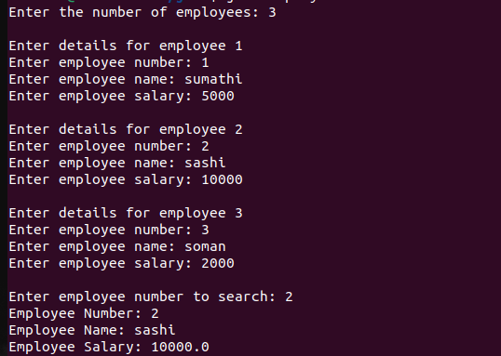

EXPERIMENT NO : 9

DATE : 25-02-2025

AIM : Write a Java program to store ‘n‘ strings in an array. Search for a given string. If found, print its index; otherwise, display ”String not found.”

SOURCE CODE

import java.util.Scanner;

public class StringSearch {

public static void main(String[] args) {
Scanner scanner = new Scanner(System.in);

System.out.print("Enter the number of strings you want to store: ");
int n = scanner.nextInt();
scanner.nextLine();

String[] strings = new String[n];

System.out.println("Enter the strings:");
for (int i = 0; i < n; i++) {
System.out.print("String " + (i + 1) + ": ");
strings[i] = scanner.nextLine();
}

System.out.print("\nEnter the string to search: ");
String searchString = scanner.nextLine();

boolean found = false;
for (int i = 0; i < n; i++) {
if (strings[i].equals(searchString)) {
System.out.println("String found at index: " + i);
found = true;
break;
}
}

if (!found) {
System.out.println("String not found.");
}

scanner.close();
}
}

OUTPUT
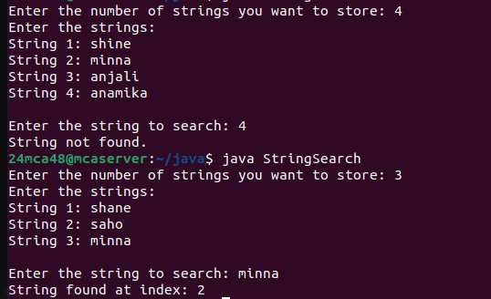

EXPERIMENT NO : 10

DATE : 25-02-2025

AIM : Write a Java program to perform various string manipulations, including finding the
length, converting to uppercase and lowercase, extracting characters and substrings, and
reversing the string.

SOURCE CODE

import java.util.Scanner;

public class StringManipulations {

public static void main(String[] args) {
Scanner scanner = new Scanner(System.in);

System.out.print("Enter a string: ");
String inputString = scanner.nextLine();

int length = inputString.length();
System.out.println("Length of the string: " + length);

String upperCaseString = inputString.toUpperCase();
System.out.println("String in uppercase: " + upperCaseString);

String lowerCaseString = inputString.toLowerCase();
System.out.println("String in lowercase: " + lowerCaseString);

char firstChar = inputString.charAt(0);
System.out.println("First character: " + firstChar);

String substring = inputString.substring(2, 5);
System.out.println("Substring from index 2 to 5: " + substring);

String reversedString = new StringBuilder(inputString).reverse().toString();
System.out.println("Reversed string: " + reversedString);

scanner.close();
}

OUTPUT
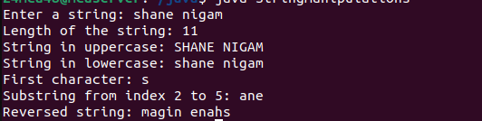

EXPERIMENT NO : 11

DATE : 25-02-2025

AIM : Write a Java program to implement hierarchical inheritance for a book management
system. Define a base class ‘Publisher‘, a derived class ‘Book‘, and two subclasses ‘Liter-
ature‘ and ‘Fiction‘. Include methods to read and display book details and demonstrate
the functionality using user input.

SOURCE CODE

import java.util.Scanner;

class Publisher {
String publisherName;
String publisherAddress;

void readPublisherDetails(Scanner scanner) {
System.out.print("Enter publisher name: ");
publisherName = scanner.nextLine();
System.out.print("Enter publisher address: ");
publisherAddress = scanner.nextLine();
}

void displayPublisherDetails() {
System.out.println("Publisher Name: " + publisherName);
System.out.println("Publisher Address: " + publisherAddress);
}
}

class Book extends Publisher {
String bookTitle;
String author;
double price;

void readBookDetails(Scanner scanner) {
System.out.print("Enter book title: ");
bookTitle = scanner.nextLine();
System.out.print("Enter author name: ");
author = scanner.nextLine();
System.out.print("Enter book price: ");
price = scanner.nextDouble();
scanner.nextLine();
}

void displayBookDetails() {
System.out.println("Book Title: " + bookTitle);
System.out.println("Author: " + author);
System.out.println("Price: " + price);
}
}

class Literature extends Book {
String genre;

void readLiteratureDetails(Scanner scanner) {
readBookDetails(scanner);
System.out.print("Enter genre of literature: ");
genre = scanner.nextLine();
}

void displayLiteratureDetails() {
displayBookDetails();
System.out.println("Genre: " + genre);
displayPublisherDetails();
}
}

class Fiction extends Book {
String subGenre;

void readFictionDetails(Scanner scanner) {
readBookDetails(scanner);
System.out.print("Enter fiction subgenre: ");
subGenre = scanner.nextLine();
}

void displayFictionDetails() {
displayBookDetails();
System.out.println("Subgenre: " + subGenre);
displayPublisherDetails();
}
}

public class BookManagementSystem {

public static void main(String[] args) {
Scanner scanner = new Scanner(System.in);

Literature literatureBook = new Literature();
Fiction fictionBook = new Fiction();

System.out.println("\nEnter details for Literature book:");
literatureBook.readPublisherDetails(scanner);
literatureBook.readLiteratureDetails(scanner);
System.out.println("\nLiterature Book Details:");
literatureBook.displayLiteratureDetails();

System.out.println("\nEnter details for Fiction book:");
fictionBook.readPublisherDetails(scanner);
fictionBook.readFictionDetails(scanner);
System.out.println("\nFiction Book Details:");
fictionBook.displayFictionDetails();

scanner.close();
}
}

OUTPUT
